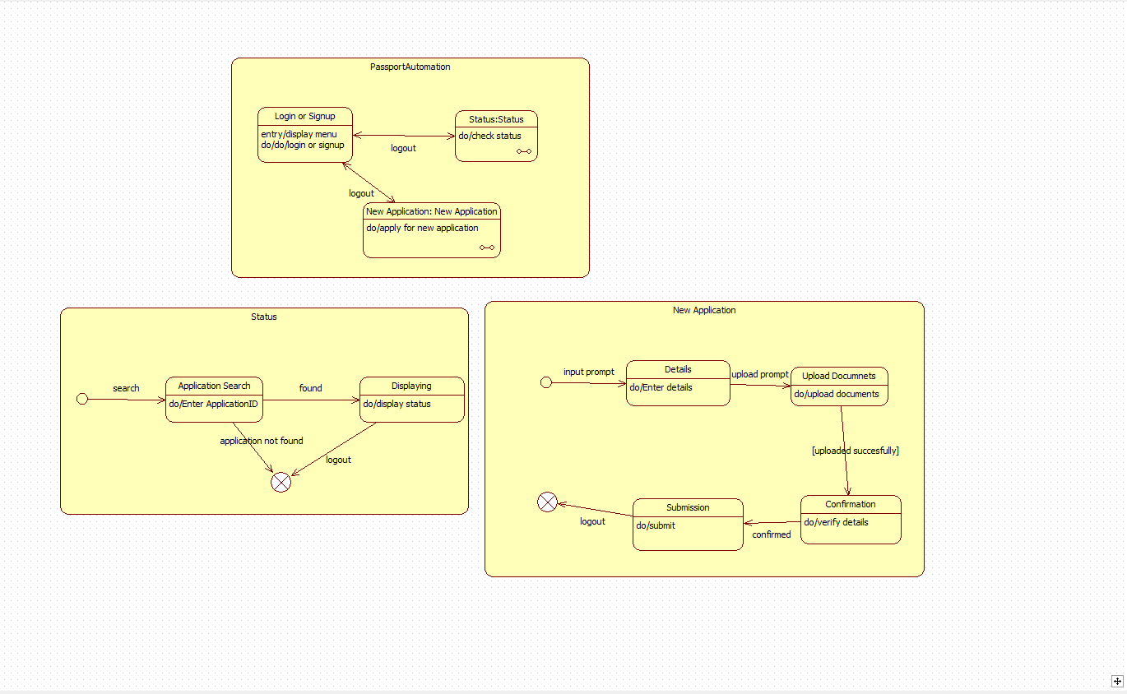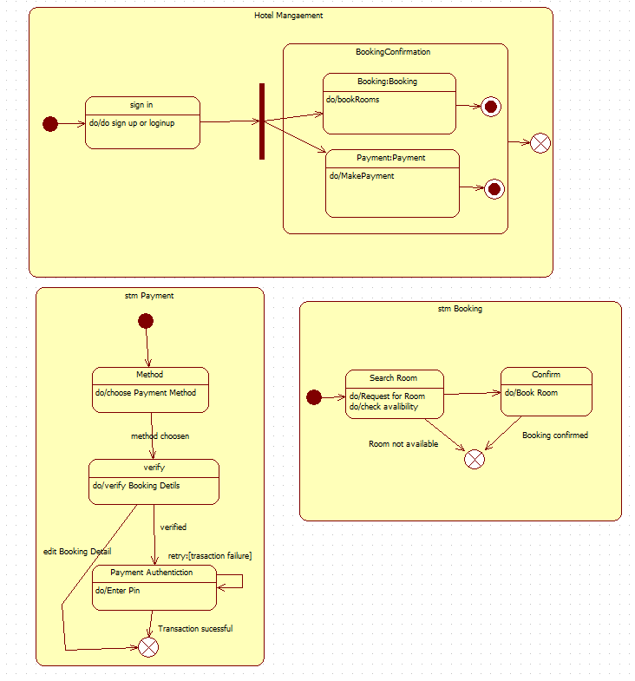

**1.PASSPORT AUTOMATION STATE DIAGRAM**

**2.HOTEL MANAGEMNT SYSTEM**

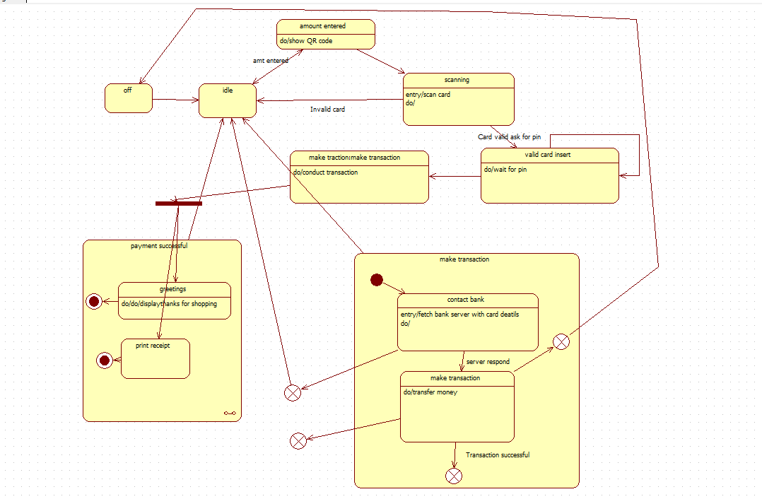

**3.CREDIT CARD PROCESSING**

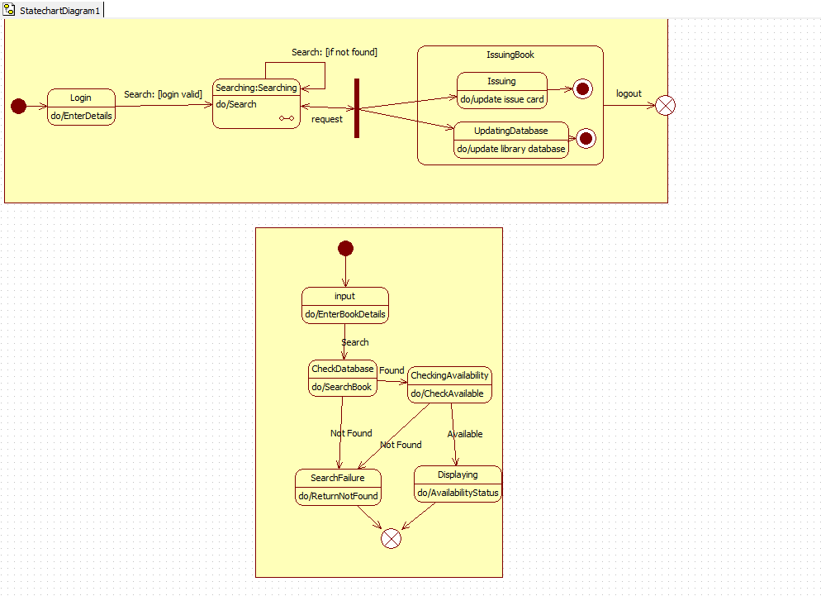

**4.LIBRARY MANAGEMENT SYSTEM**